Club project spotlights :

Students worked on an eco–friendly craft project – Designing and Making Colourful book and pen stand using
Wrap Wonders

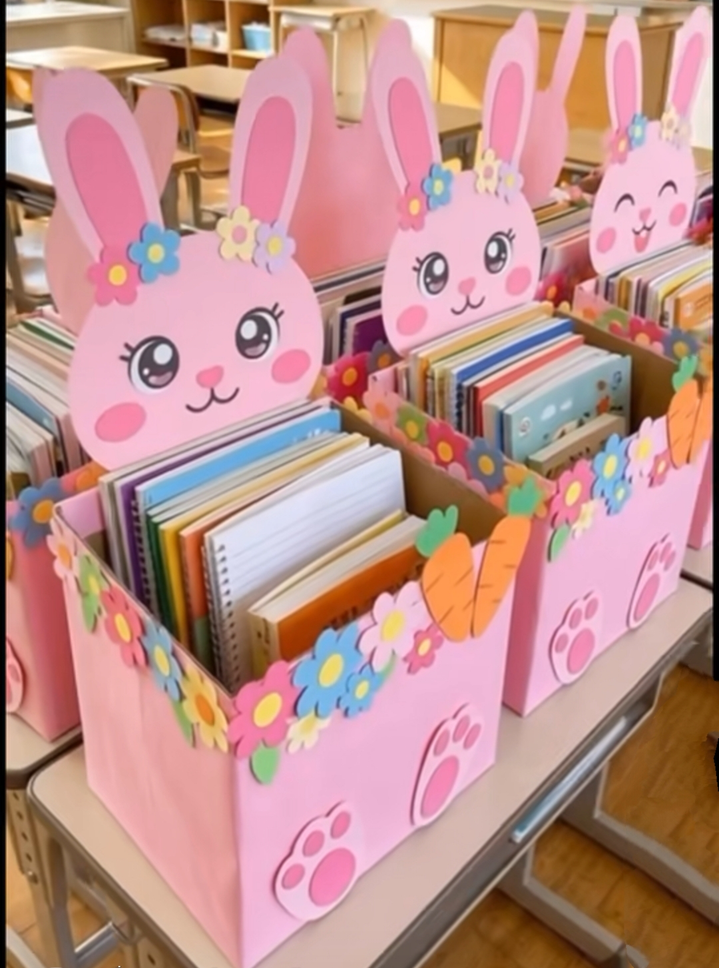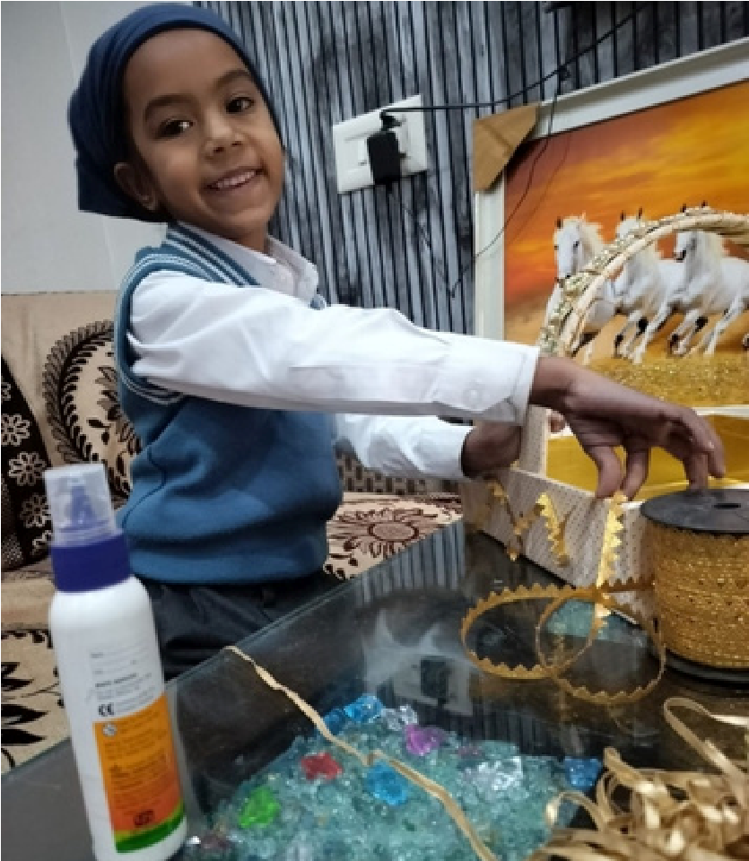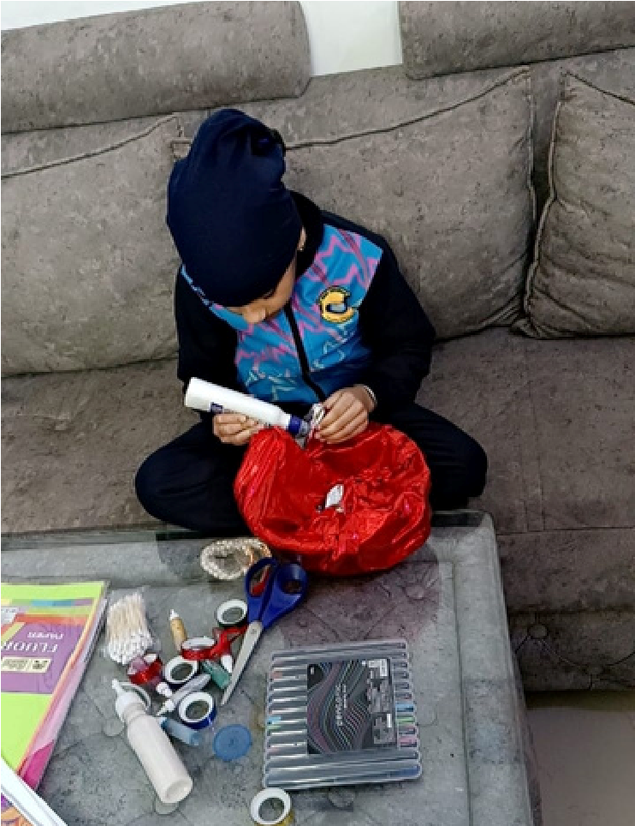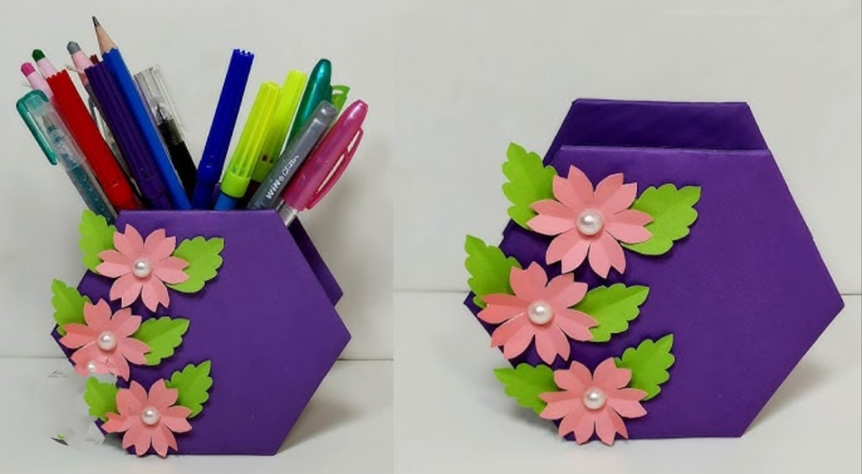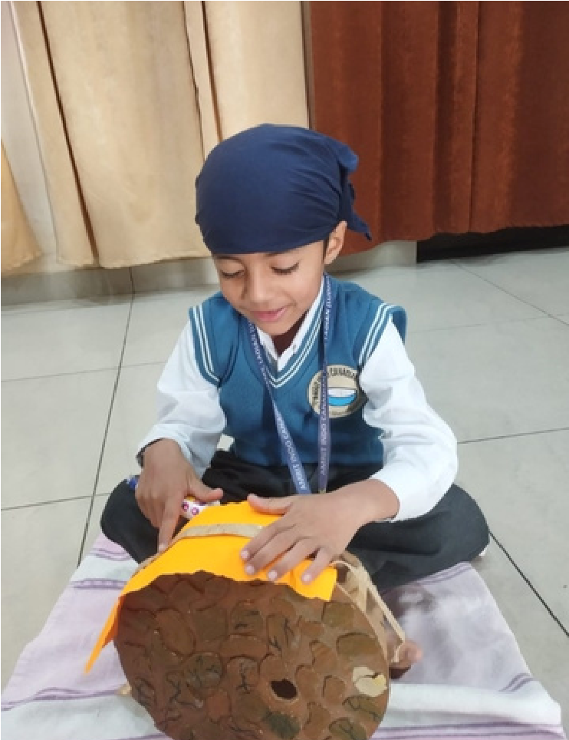
Student Voices :

reusable, recyclable and biodegradable materials.
students felt proud when their basket was ready. It looked so colourful and
pretty!”

They loved decorating our own gift baskets — it felt like creating a special surprise!”

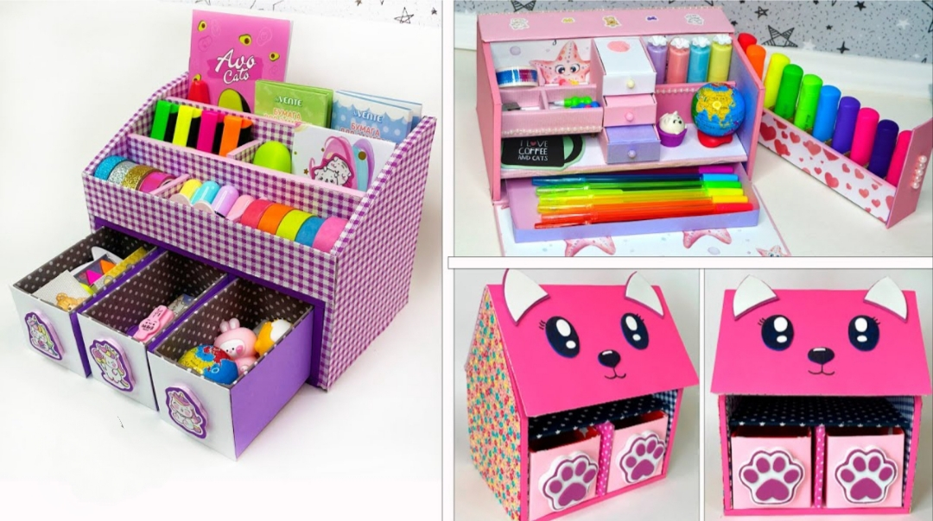

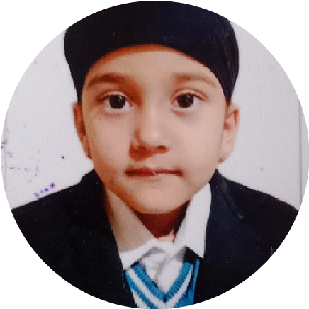
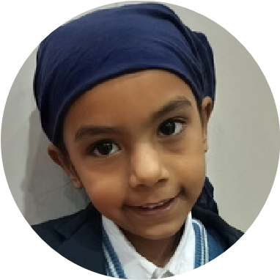
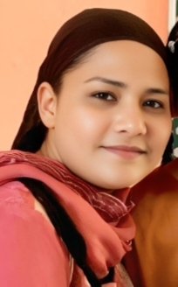
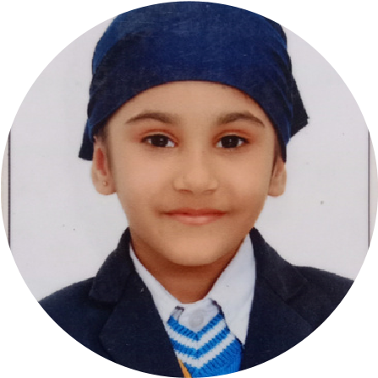
Anant Kaur
UKG D

Amayra
UKG C
Sehajbadhan

UKG D
Seerat Kaur
UKG D
Project Report and Skill Development
Deeper Dive
Ramandeep Kaur 6/12/2025
Wrap Wonders

Imagination in every fold
Project Goals:

To
encourage
teamwork
as
children
share
materials
and
ideas.
Process/ Steps:

Select a small or medium basket suitable for holding the it
ems.

Aesthetic
Sense
–
choosing
colours,
materials,
and
decoration
styles.
Decision-Making – selecting what to include in the hamper.
Skills Learned :
Challenges and solutions :
Ramandeep Kaur
Meet the Team :
To build fine motor skills through cutting, pasting, folding, and
arranging items.
Add ribbons, flowers, beads, stickers, or lace around the baskets
to make it attractive.

Students get confused about colour combinations.

Show 2–3 sample stand or give a simple colour theme
(
red–yellow / blue–white
).

